Harrison’s Memorial Weekend
CAR & BIKE SHOW

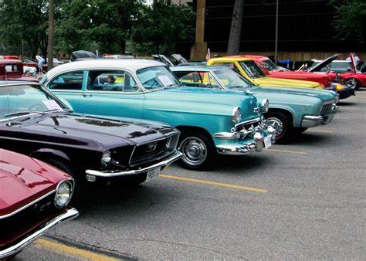
Where: Downtown Harrison Date: May 28, 2023 Time: 11am to 3pm

To Register a Vehicle:
$10 in Advance:
Call (989)-539-6011
$15 Day of Show:
Register From 10am to 11am
For more information:
Call (989)-539-6011 or Visit harrisonchamber.com/events

*Handmade Trophies * Goody Bags To First 50 * 50/50 Raffle * Music, Food, & Vendors*
= = = = = = = = = = = = = = = = = = = = = = = = = = = = = = = = = = = = = = = = = = = = = = = =
Name: Phone Number:
Mailing Address:
Year, Make, & Model of Vehicle being Entered:
Type of Entry:
American Classic (74’ and Earlier) American Modern (75’ to Present)
Motorcycle Import Rat Rod
Registration: $10-Advanced Registration $15-Day of Show
Please make checks payable to: Harrison Chamber of Commerence
Questions, or to Register by Credit Card: Call (989)-539-6011
You Can Mail Your Form & Payment to: Harrison Chamber, P.O. Box 682, Harrison, MI, 48625

